SI Statics
Session 3: February 9, 2022
7–8 pm BU 127
Leader: Sophia Helmkamp

Problems:
Find the tension in cables CA and CB, given an angle θ = 40° and a cylinder with a weight of 100 N. (3-10 from Hibbeler Statics, 13th ed., modified)
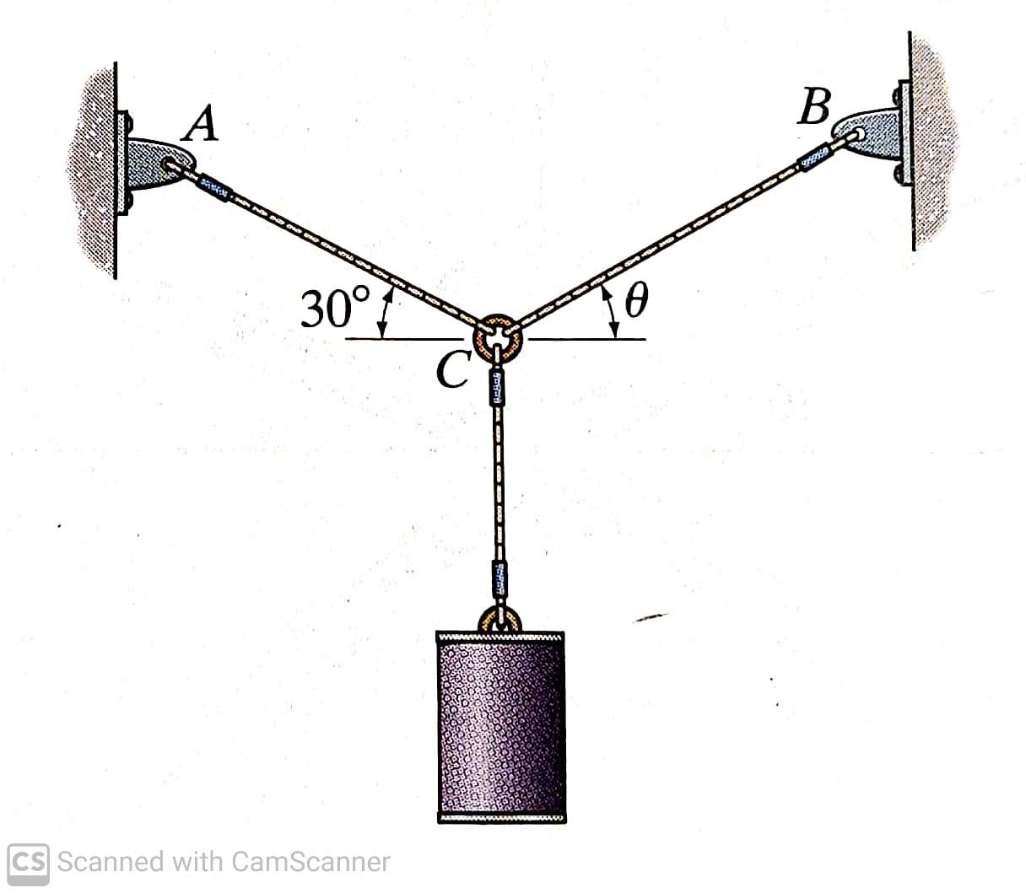
The unstretched length of AB is 3 m. If the block is held in the equilibrium position shown, determine the weight of the block at D. (3-19 from Hibbeler Statics, 13th ed., modified)
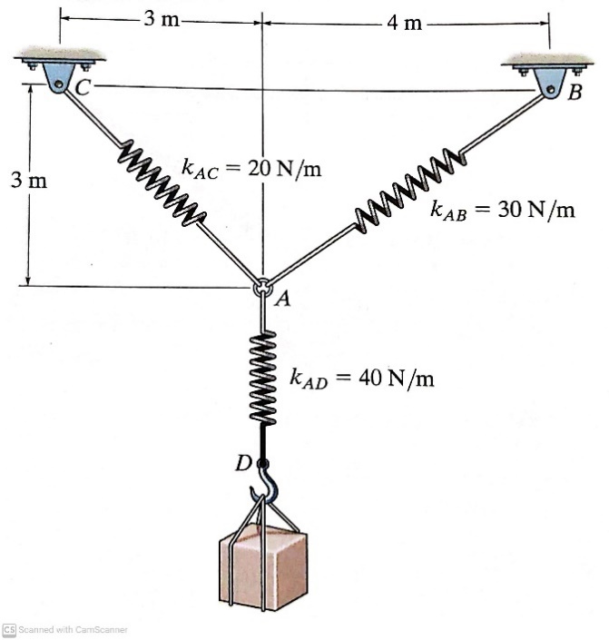
Cords AB and AC can each sustain a maximum tension of 800 lb. If the drum has a weight of 900 lb, determine the smallest angle θ at which they can be attached to the drum. (3-4 from Hibbeler Statics, 13th ed.)
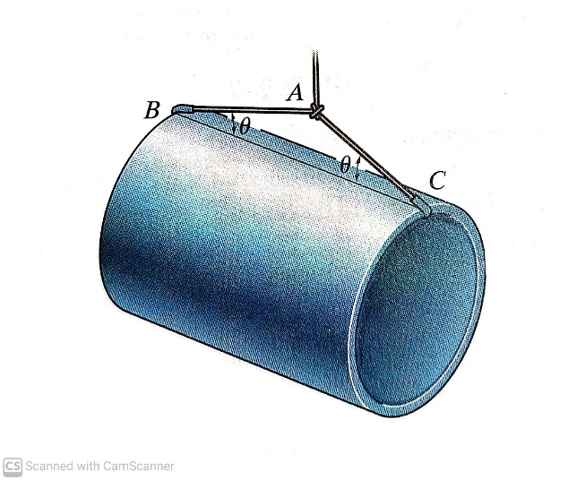
Cable ABC has a length of 5 m. Determine the position x and the tension developed in ABC required for equilibrium of the 1000-N sack. Neglect the pulley at B. (3-35 from Hibbeler Statics, 13th ed.)
