SI Statics
Session 4: February 23, 2022
7–8 pm BU 127
Leader: Sophia Helmkamp

Problems:
Determine the moment of the force about point O. (F4-4 from Hibbeler Statics, 13th ed.)
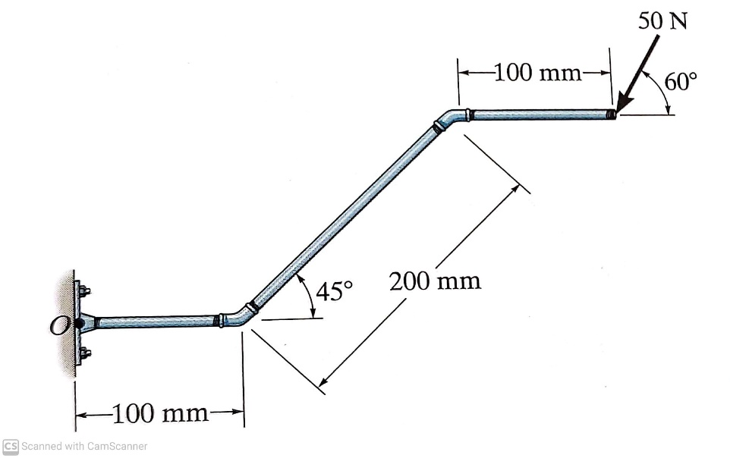

Determine the total moment about point A. (4-7 from Hibbeler Statics, 13th ed., modified)
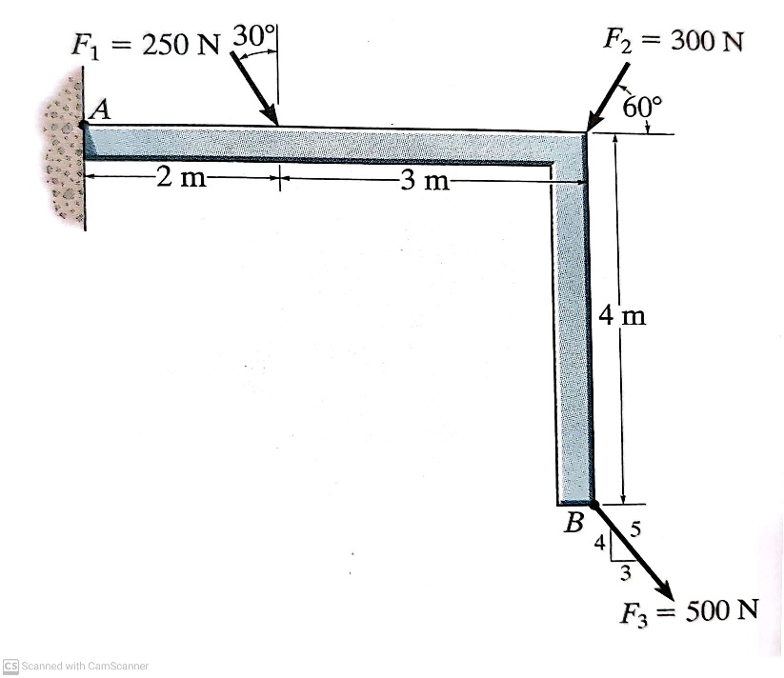
Use the cross product to determine the resultant moment (in Cartesian form) produced by forces F_{B} and F_{C} about point O. (4-34 from Hibbeler Statics, 13th ed., modified)
