SI Statics
Session 7: March 23, 2022
7–9 pm EN 2110
Leader: Sophia Helmkamp

Problems:
The beam is supported by a pin at A and the strut BC. Determine the reactions at A and B. (5-14 from Hibbeler Statics, 13th ed.)
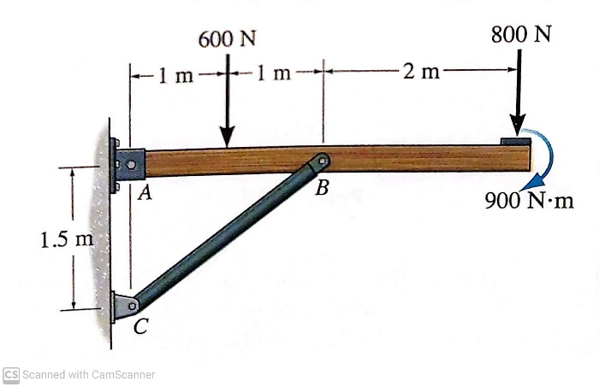
The ramp of a ship has a weight of 200 lb and a center of gravity at G. Determine the cable force in CD needed to just start lifting the ramp (i.e., so the reaction at B becomes zero). Also determine the horizontal and vertical components of the force at the hinge (pin) at A. (5-34 from Hibbeler Statics, 13th ed.)
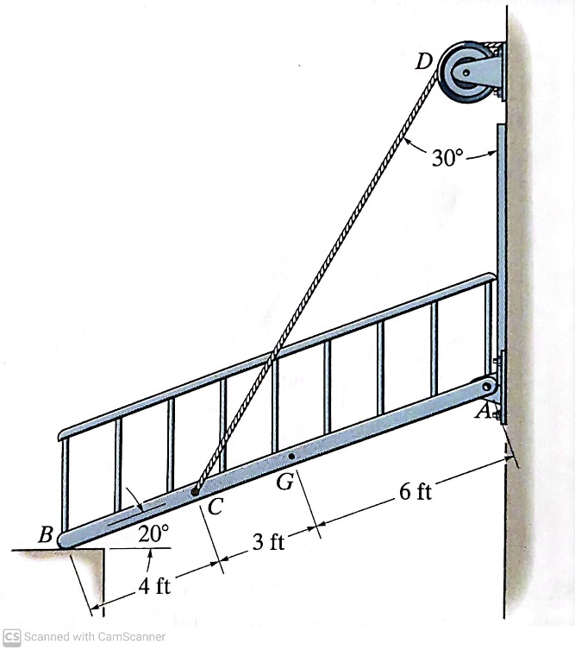
The rod is supported by smooth journal bearings at A, B, and C. Find reactions at these points. (F5-9 from Hibbeler Statics, 13th ed.)
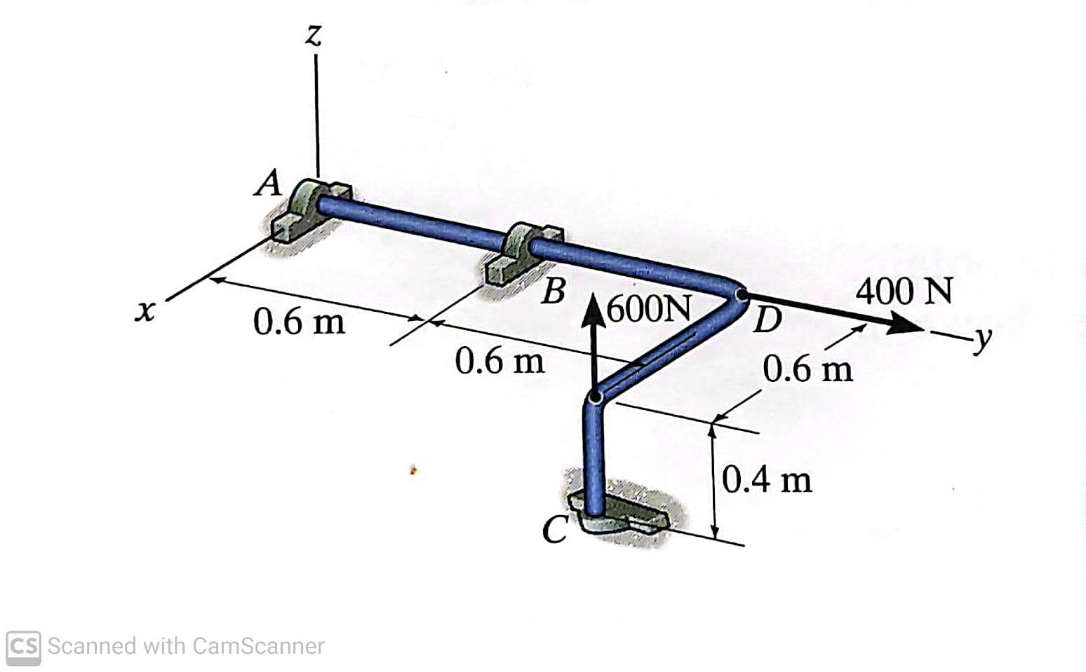

The cable CED can sustain a maximum tension of 800 lb before it fails. Determine the greatest vertical force F that can be applied and the resulting reaction at A. (5-74 from Hibbeler Statics, 13th ed.)
