SI Statics
Session 8: March 29, 2022
5–6 pm BU 121
Leader: Sophia Helmkamp

Find the magnitude of the reactions at A and B and the orientation of the reaction at A. (5-15 from Hibbeler Statics, 13th ed., modified)
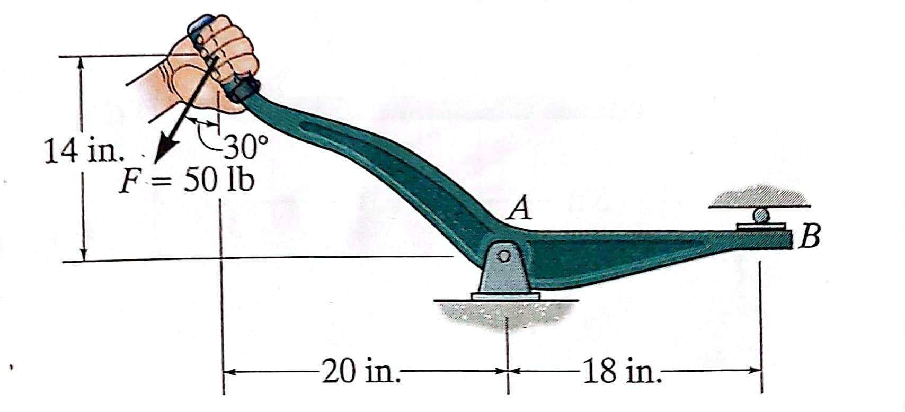

For the truss below:
- Use rigid-body equilibrium of the entire structure to find reactions at A and I
- Identify zero-force members
- Using the Method of Joints, solve for the forces in all other members
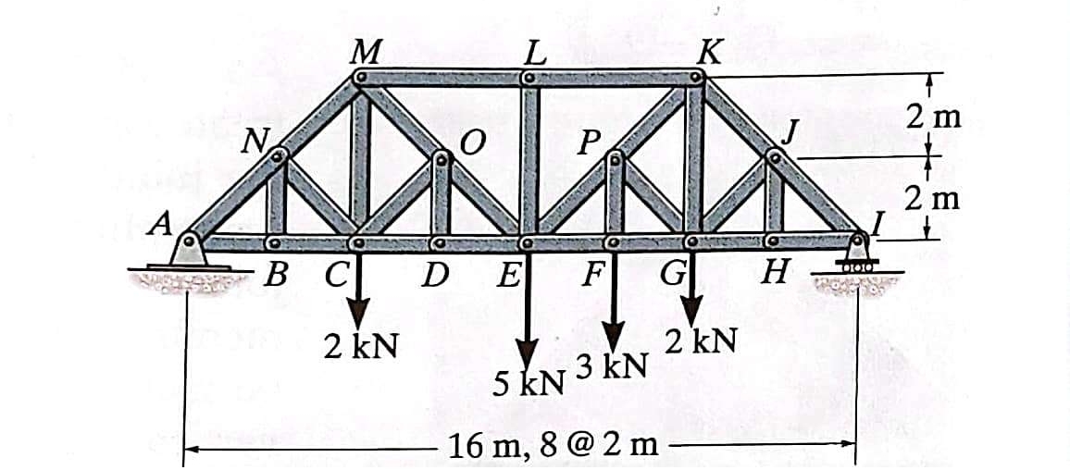
(6-46/7 from Hibbeler Statics, 13th ed., modified)

