SI Statics
Session 9: April 6, 2022
7–8 pm BU 127
Leader: Sophia Helmkamp

For the truss below, use the Method of Sections to find the force in links EF, EP, and LK (6-46/7 from Hibbeler Statics, 13th ed., modified).
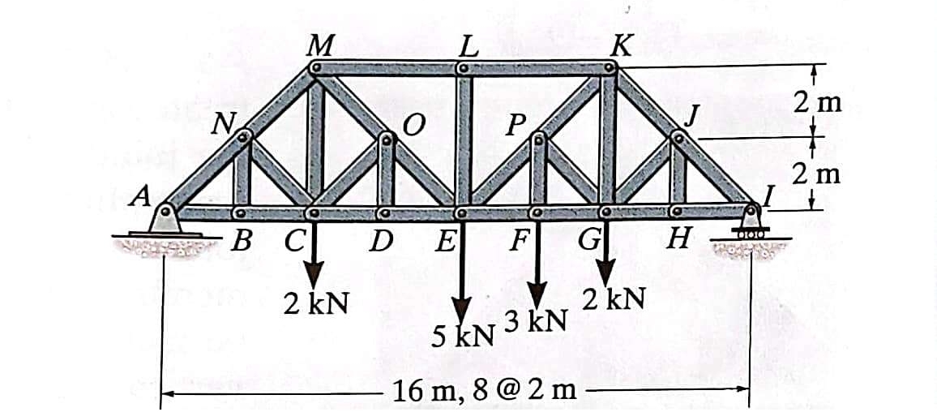

Determine the force P required to hold the 150 kg crate in equilibrium (6-64 for Hibbeler Statics).
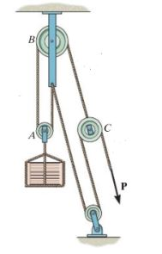
Determine the components of the reaction at A and C (F6-21 from Hibbeler Statics, 13th ed.).
