SI Statics
Session 10: April 13, 2022
7–8 pm BU 127
Leader: Sophia Helmkamp

Find the centroid $\overline{x}$ of the area. (9-28 from Hibbeler Statics, 13th ed.).
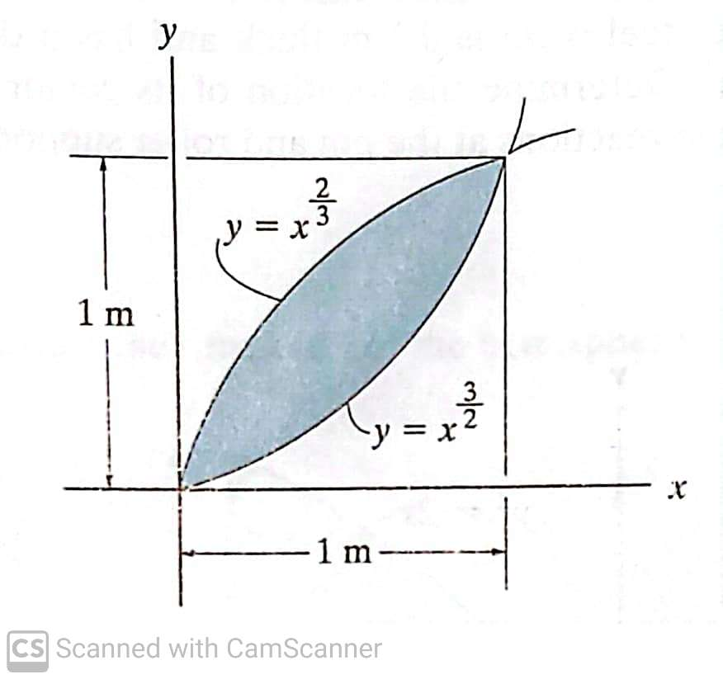
Find the centroids $\overline{x}$ and $\overline{y}$ of the cross-sectional area of the angle. (9-59 for Hibbeler Statics, 13th ed.).
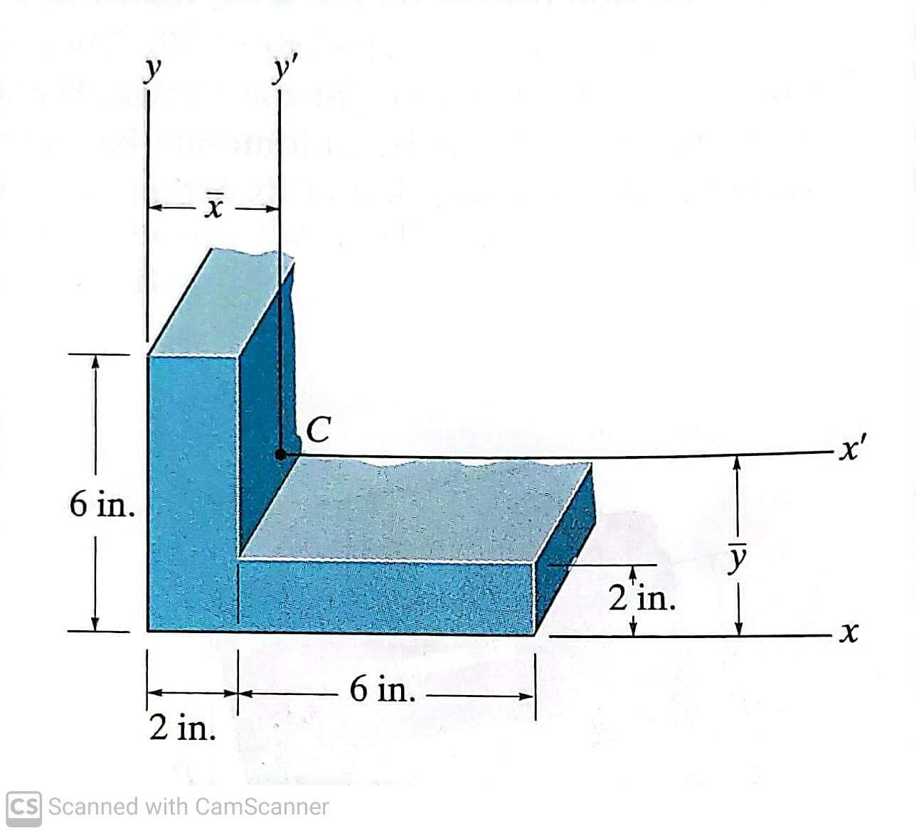
The rectangular gate is 3 m high by 1 m wide and has a frictionless hinge at the bottom. If the fluid on the left side of the gate has a density of 1600 kg/m³, find the magnitude of the force F required to keep the gate closed. (#61 from NCEES FE Mechanical practice exam 2020).
