SI Statics
Final Review Session: May 2, 2022
7–8 pm BU 121
Leader: Sophia Helmkamp

Extra Practice Problems:

Express the position vector both in Cartesian vector form and as a magnitude with coordinate direction angles. (F2-19 from Hibbeler Statics, 13th ed.)
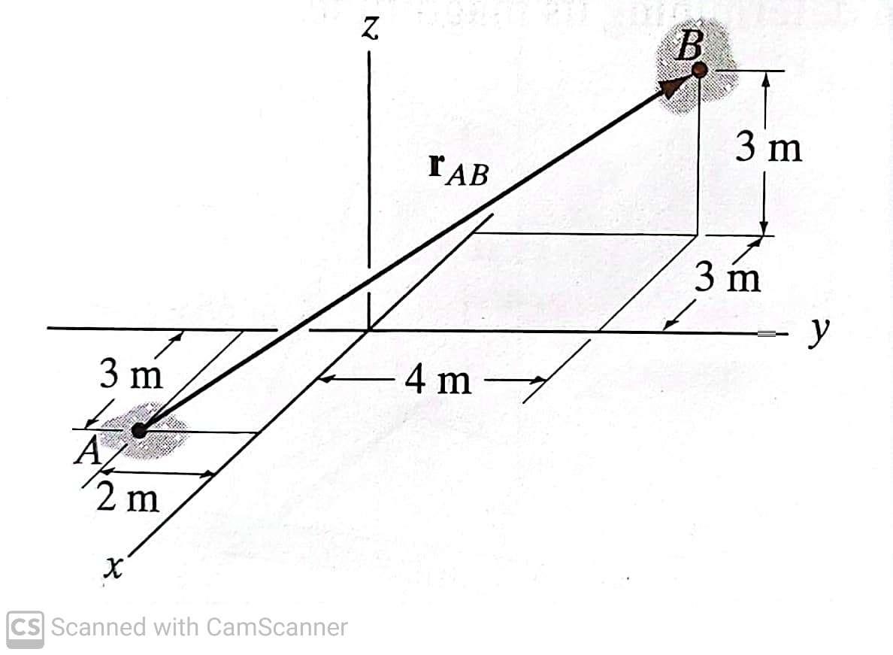
Determine the magnitude of the moment of the force F = [300 i - 200 j + 150 k] N about the OA-axis. (F4-14 from Hibbeler Statics, 13th ed.)
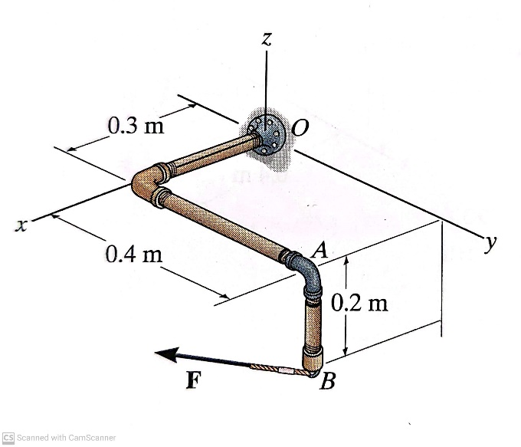

Determine the components of the reaction that thrust bearing A and cable BC exert on the bar. (F5-12 from Hibbeler Statics, 13th ed.)
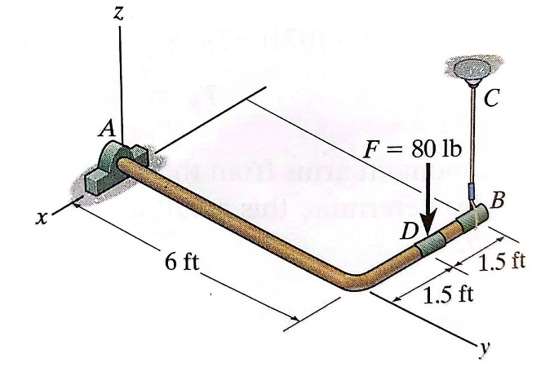
Due to unequal distribution of fuel in the wing tanks, the centers of gravity for the airplane fuselage A and wings B and C are located as shown. If these components have weights of 45,000 lb, 8000 lb, and 6000 lb respectively, determine the normal reactions of the wheels D, E, and F on the ground. (5-65 from Hibbeler Statics, 13th ed.)
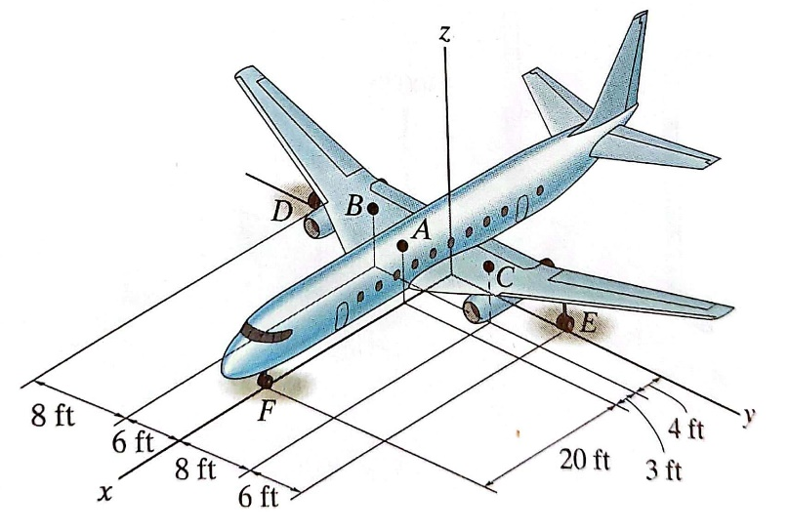
Determine the force in members BC, CF, and FE. (F6-7 from Hibbeler Statics, 13th ed.)
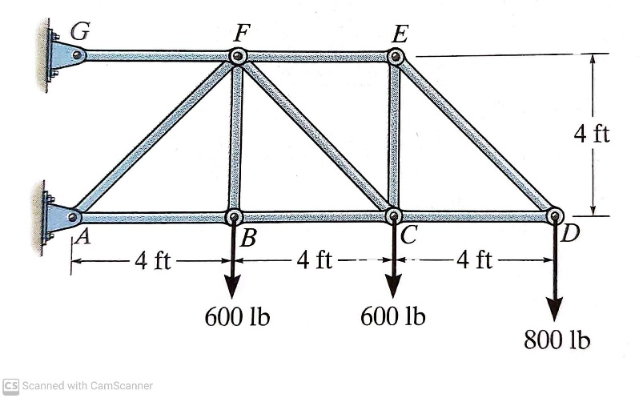
Determine the reaction at pin C. (F6-14 from Hibbeler Statics, 13th ed.)
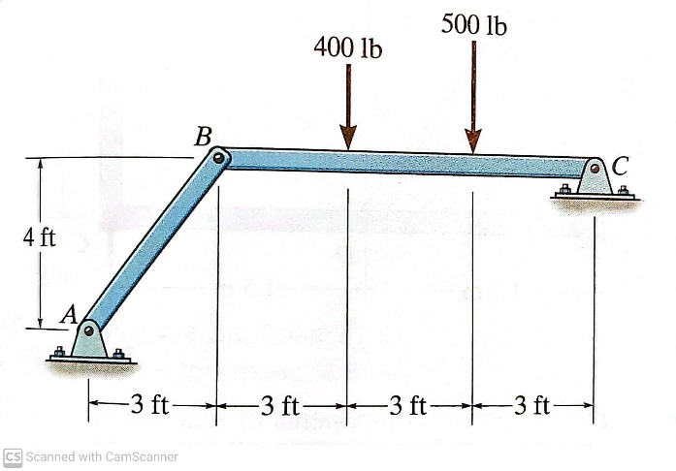
Locate the x- and y- centroids of the area. (9-13/14 from Hibbeler Statics, 13th ed.)
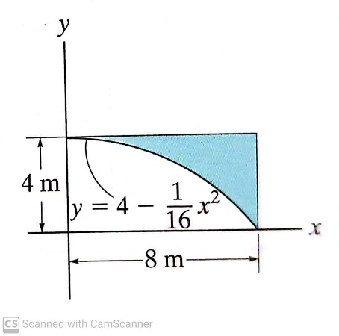
Determine the magnitude of the hydrostatic force acting on gate AB and the reactions at A and B. (F9-20 from Hibbeler Statics, 13th ed., modified)
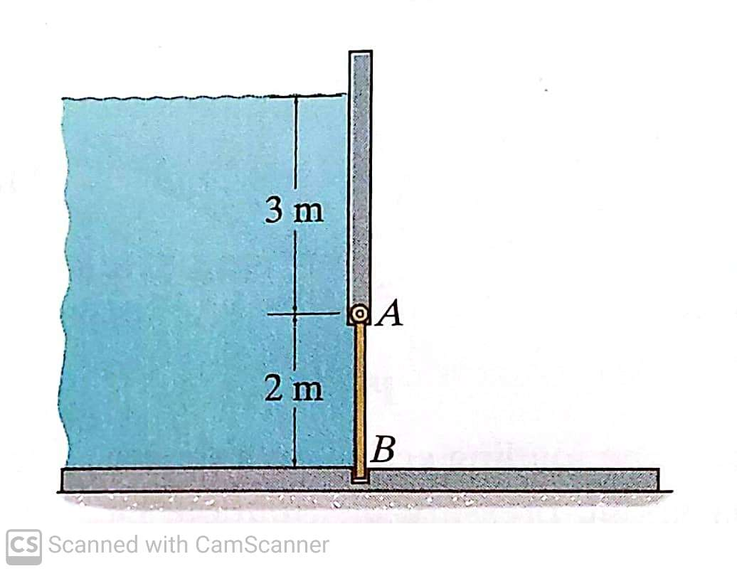

The block brake consists of a pin-connected lever and friction block at B. The coefficient of static friction between the wheel and the lever is 0.3, and a torque of 5 N-m is applied to the wheel. Determine if the brake can hold the wheel stationary when the force applied to the lever is (a) 30 N and (b) 70 N. (8-7 from Hibbeler Statics, 13th ed.)
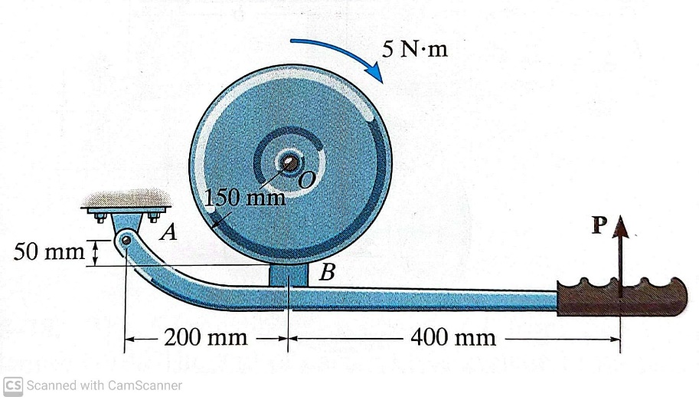
Determine the shear and moment as a function of x, then draw the shear and moment diagrams. (F7-8 from Hibbeler Statics, 13th ed.)
