SI Week 3: Right Triangle Trig and Circular Trig

  - In the figure below, ΔXYZ ~ ΔCAB. Find tan(A), sin(A), and cos(A).
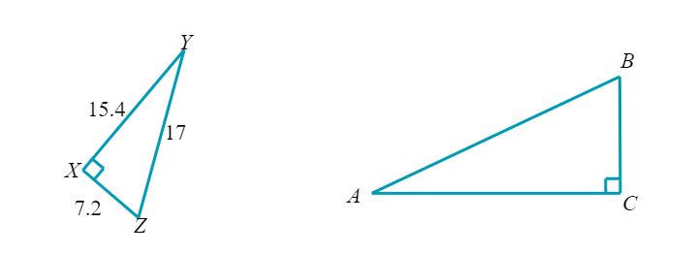

  - In the figure below, ΔXYZ ~ ΔBAC. Find Sin(C), tan(C), and cos(C)
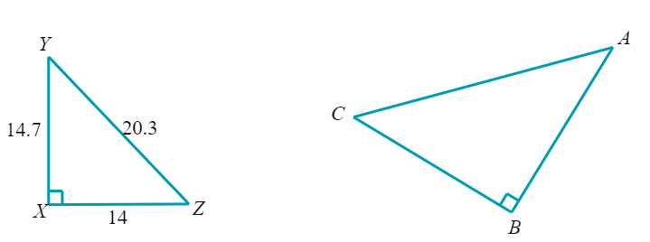

- Read the following word problems and determine the asked value (Hint: Draw a picture)
  - Looking up, Brian sees 2 hot air balloons in the sky. He determines that the lower, red hot air balloon is 515 meters away, at an angle of 15° from vertical. The higher, blue hot air balloon is 840 meters away, at an angle of 22° from the vertical. How much higher is the blue balloon than the red one?

  - A surveyor wants to know the length of a tunnel built through a mountain. According to his equipment, he is located 340 meters from the one entrance of the tunnel, at an angle of 58° to the perpendicular. Also according to his equipment, he is 193 meters from the other entrance of the tunnel at an angle of 21° to the perpendicular. Based on these measurements, find the length of the whole tunnel.

- The following questions ask about a point on the unit circle
  - Suppose that $(-\frac{\sqrt{2}}{2},y)$ is a point in Quadrant 3 on the unit circle. Find the exact value of y.

  - Suppose that $(x,\frac{5}{13})$ is a point in Quadrant 2 on the unit circle. Find the exact value of x.

- Find the following values of the trigonometric identities
  - Let θ be an angle such that $\sin\left(θ\right)=-\frac{4}{5}$ and $cot⁡(θ)<0$. Find the exact values of tan(θ) and sec(θ)

  - Let θ be an angle such that $\csc\left(θ\right)=\frac{3}{2}$ and $\cot\left(θ\right)>0$. Find the exact values of tan(θ) and cos(θ)

