Week 4 SI
- For the following θ values, find the exact value of the expressions
  - If θ = 135°, find $cos⁡(-θ)$, $cos⁡(2θ)$, and $\cos^{2}⁡(θ)$

  - If θ = $\frac{π}{4}$, find $sin⁡(-θ)$, $\sin^{2}θ$, and $sin 2θ$.

- Find the amplitude, phase shift, and period of the functions below
  - $y=4\cos\left(3x+\frac{π}{2}\right)+3$

  - $y=-3\sin\left(3x-\frac{π}{4}\right)-1$

- Read the following word problems and complete them
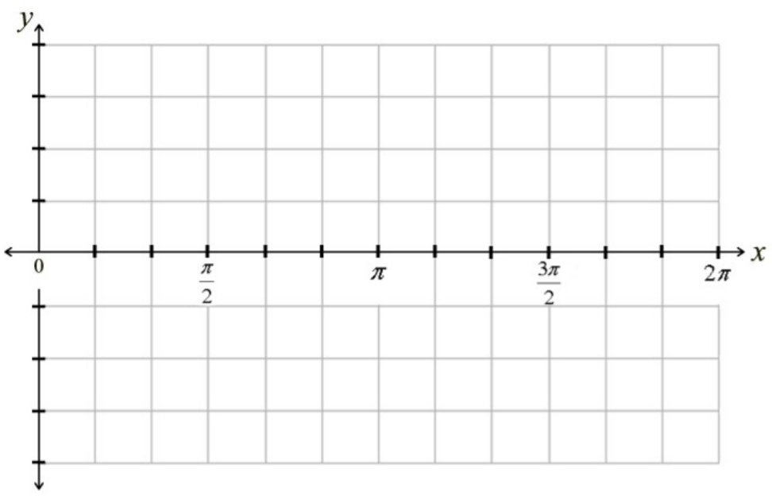
  - The sound waves from the music playing in the room right now are moving in simple harmonic motion with a period of 6 seconds and amplitude of 3 cm. At t=0 seconds, its displacement from rest is -3cm, and initially move in the positive direction. Write an equation modeling this displacement as a function of time and draw a graph to represent the equation.

  - A buoy floating in the sea is bobbing in simple harmonic motion with period 4 seconds and amplitude 15 inches. Its displacement d from sea level at time t=0 seconds is 0 inches, and initially it moves downwards. Give the equation modeling the displacement as a function of t and graph the equation.

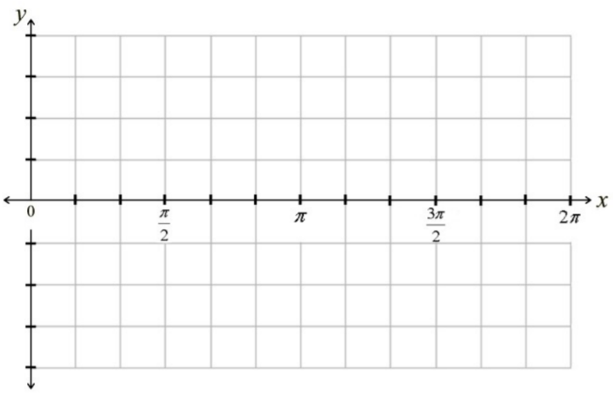
- Graph the following trigonometric functions
  - $y=3csc⁡(3x+\frac{π}{2}$)

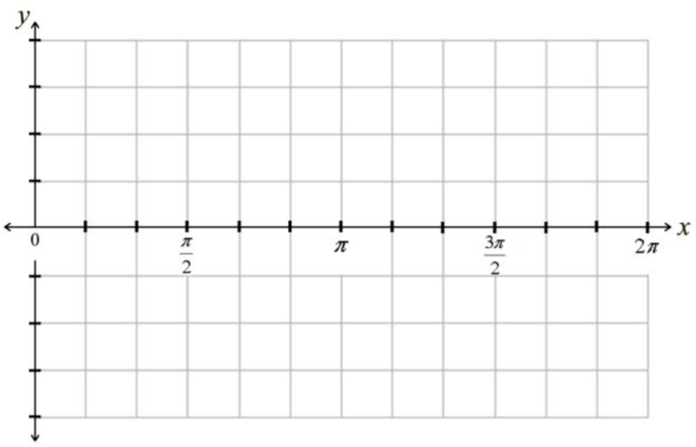
  - $y=-\frac{1}{4}sec(2x-π)$

