Week 5 SI: Exam Review

  - For a given location, the daily number of sunlight hours fluctuates throughout the year. Suppose that the number of sunlight hours is given by the function $D\left(t\right)=12+8.7cos⁡(\frac{2π}{365}t)$. In this equation,, D(t) is the number of hours of sunlight in a day, and t is the number of days after December 21st. Find the minimum number of hours of sunlight in a day, the amplitude of D (hours of sunlight in a day), and the period in days.

  - Suppose that before your upcoming test, you are very nervous. You’re curious on if you are having a heart attack, or if it’s just the caffeine and stress making your heartbeat like this. Since you’re all ridiculously smart, you can instantly tell the equation of your heartbeat is given by $p\left(t\right)=88+21cos⁡(104πt)$. Find the time for one full cycle of p, your minimum blood pressure, and the frequency as p.

- Write an equation for the following graphs
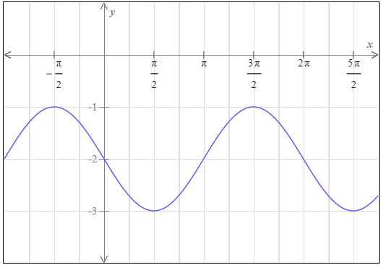
  - b.
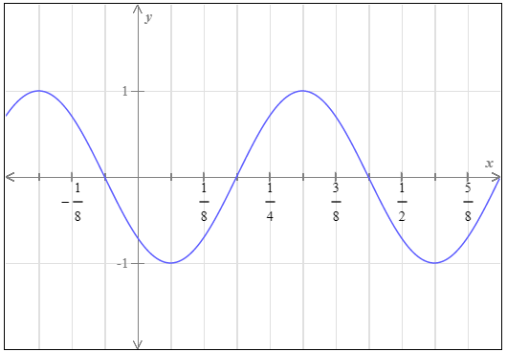

- Read the following problems and solve for the asked value
  - A Ferris wheel at a carnival has a radius of 35 feet. Suppose it turns at a rate of 1 revolution per minute. Find the
    - Angular speed of the wheel in radians per minute
    - Linear speed of a passenger in feet per minute

  - A cyclist is riding a bicycle whose wheels have a diameter of 24 inches. Suppose he is riding at 24 miles per hour. Find the,
    - Angular speed of the wheels in radians per minute
    - Find the number of revolutions the wheels make per mimute

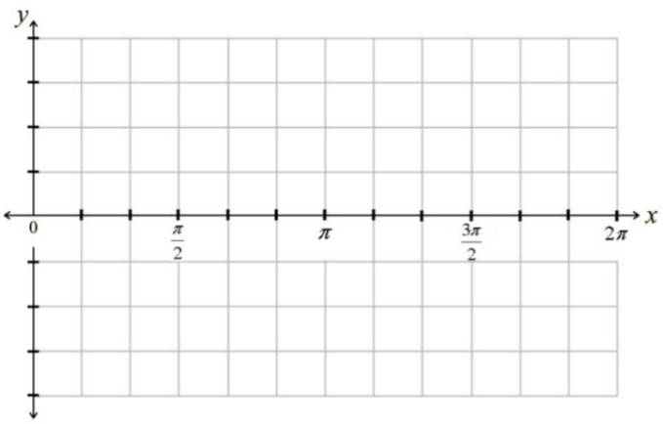
- Sketch the following graphs of tangent or cotangent
  - $y=3cot⁡(x+\frac{π}{2})$

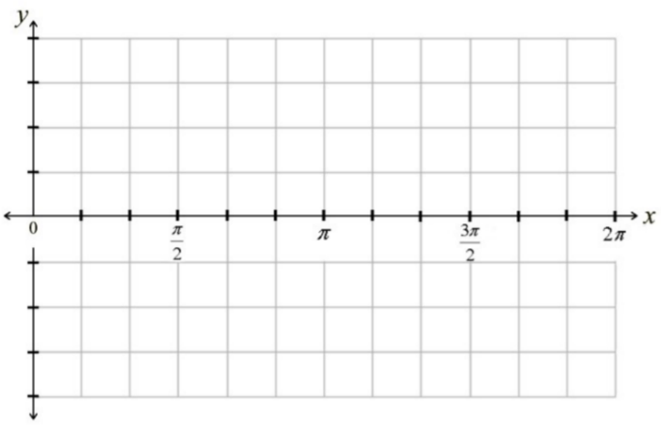
  - $y=3tan⁡(x-\frac{3π}{4})$

