SI Week 11
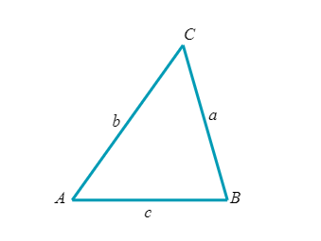
- Solve the following triangles
  - Suppose A=115°, C=35°, and c=70

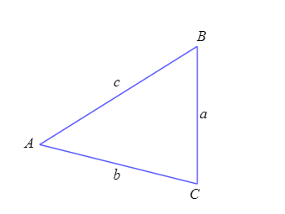

  - Suppose b=67, c=73, and B=30°

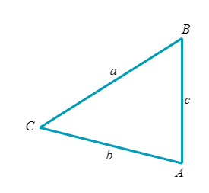
- Solve the following triangles
  - Suppose B=117°, a=16, and c=61

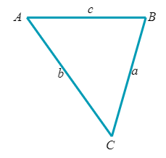
  - Suppose that a=59, b=70, c=38

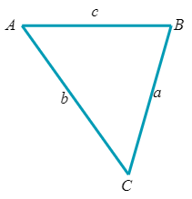
  - Suppose that B=34°, a=10, c=40

- Solve the following word problems
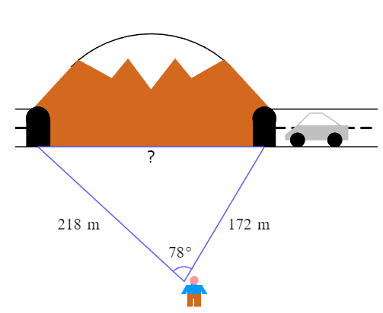
  - Chad wants to know the length of a tunnel built through a mountain. To do so, he makes the measurements shown in the figure below. Use these measurments to find the length of the tunnel.

  - If a plane a leaves Denver and flies 131 km to Fort Collins (not accurate), then turns at an angle of 44° and flies 108 km to Cheyenne. What angle with respect due north could the pilot have used to fly directly from Denver to Cheyenne?

  - Justin is flying 2 kites. He has 101 feet of string out to one kite and 110 feet out to the other. The angle formed by the 2 strings is 34°. How far apart are the kites?

