SI Week 12
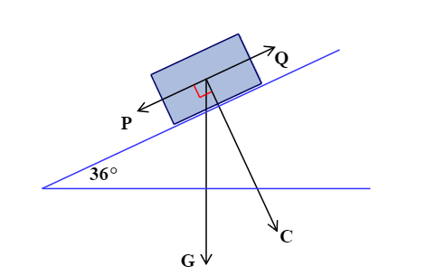
- Find the asked for forces in the problems below
  - A crate in on a ramp that is at a 36° incline to the horizontal. The force C the crate exerts against the ramp has a magnitude of 690 N. Find the magnitude of Q required to prevent the crate from sliding down the ramp, and the weight of the crate.

  - A cart weighing 67.4 pounds is parked on a hill at a 14° incline. Find the force stopping the cart from rolling down the hill, and the force that the cart places on the hill perpendicularly. (There are 4.45 Newtons in 1 pound).

  - If I am mowing my yard , while pushing the mower at a downwards angle of 71° with a force of 30N, how much work did I do after pushing the lawn mower 14 meters?

- Solve the following problems involving polar coordinates
  - Find the rectangular coordinates for the polar coordinates ($-2, \frac{π}{4})$

  - Find the rectangular coordinates for the polar coordinates ($-1, \frac{11π}{6})$

  - Convert the equation $x^{2}+y^{2}-3x=0$ to polar form, then solve the found equation for r.

  - Convert the equation $y=-\frac{\sqrt{3}}{3}x$ to polar form

