Final Exam Review
- Read the following problems carefully and find the missing arclength, radius, or angle.
  - If the radius of a record is .2 meters, and the arclength is 19 cm, what is the angle that these 2 distances make?

  - A car is driving around a racetrack while testing its airbags. The racetrack is a perfect circle, and the distance from the center of the track to the car is 400 centimeters. The angle that the car drives from the beginning of its run is 96°, then it stops when it hits a wall. How far along the track did it drive in meters?

- Read the following word problems and determine the asked value (Hint: Draw a picture)
  - Looking up, Brian sees 2 hot air balloons in the sky. He determines that the lower, red hot air balloon is 515 meters away, at an angle of 15° from vertical. The higher, blue hot air balloon is 840 meters away, at an angle of 22° from the vertical. How much higher is the blue balloon than the red one?

  - A surveyor wants to know the length of a tunnel built through a mountain. According to his equipment, he is located 340 meters from the one entrance of the tunnel, at an angle of 58° to the perpendicular. Also according to his equipment, he is 193 meters from the other entrance of the tunnel at an angle of 21° to the perpendicular. Based on these measurements, find the length of the whole tunnel.

- For the following θ values, find the exact value of the expressions
  - If θ = 135°, find $cos⁡(-θ)$, $cos⁡(2θ)$, and $\cos^{2}⁡(θ)$

  - If θ = $\frac{π}{4}$, find $sin⁡(-θ)$, $\sin^{2}θ$, and $sin 2θ$.

- Read the following word problems and complete them
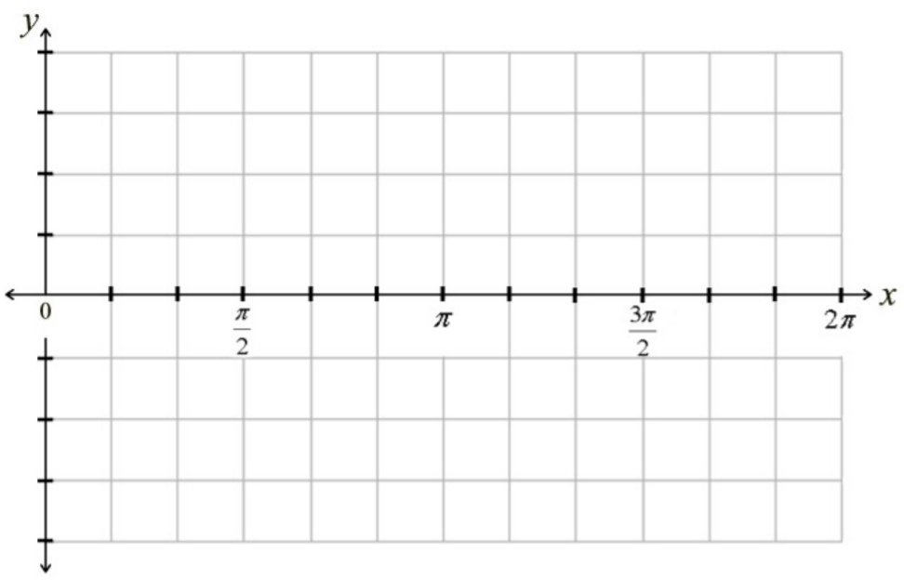
  - The sound waves from the music playing in the room right now are moving in simple harmonic motion with a period of 6 seconds and amplitude of 3 cm. At t=0 seconds, its displacement from rest is -3cm, and initially move in the positive direction. Write an equation modeling this displacement as a function of time and draw a graph to represent the equation.

  - A buoy floating in the sea is bobbing in simple harmonic motion with period 4 seconds and amplitude 15 inches. Its displacement d from sea level at time t=0 seconds is 0 inches, and initially it moves downwards. Give the equation modeling the displacement as a function of t and graph the equation.

- Find all solutions of the equations on the interval [0, 2π]
  - $\left(cotx+1\right)\left(cscx-1\right)=0$

  - $\left(cotx-\sqrt{3}\right)\left(2cosx-\sqrt{2}\right)=0$

  - $\left(2sinx+\sqrt{2}\right)\left(2cosx-\sqrt{3}\right)=0$

- Find the values of x in [0, 2π]
  - $3\cot^{2}x-1=0$

  - $\sec^{2}x-2=0$

  - 4$\cos^{2}x-3=0$

- Prove the following identities
  - $\tan\left(π-x\right)=-tanx$

  - $\sin\left(\frac{π}{3}+x\right)-\sin\left(\frac{π}{3}-x\right)=sinx$

  - $\frac{cos⁡(π+x)}{cos⁡(\frac{3π}{2}-x)}=cotx$

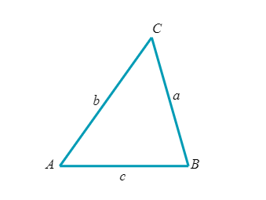
- Solve the following triangles
  - Suppose A=115°, C=35°, and c=70\

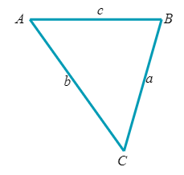
  - Suppose B=117°, a=16, and c=61

- Solve the following real-world situations.
  - The brightness of some stars can fluctuate over time (called Cephid Variable stars). The brightness of one of these is defined by $B\left(t\right)=7.7+10.7sin⁡(\frac{2π}{63}t)$. $B\left(t\right)$ represents the magnitude of brightness, and t is the time in days. During it’s first 63 days, when will the stars magnitude of brightness be 14?

  - Suppose a projectile is fired from a cannon with some initial velocity and an angle of elevation θ. The horizontal distance R(θ) is given by $R\left(θ\right)=\frac{{(v_{0})}^{2}sin2θ}{32}$. If you initially fire the cannon at 160 ft/s, and you want to hit a target 435 feet in front of you, what angle should you use?

