CHEM 1020 SI
Jan. 27th

Agenda:
Spotify playlist (write any ideas on the board)
Worksheet
Fun Chemistry Trivia

Questions:
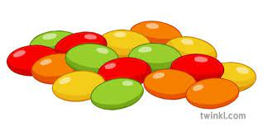
- Classification of Matter: determine if each picture or word is an element, compound, or mixture.
Saline Solution

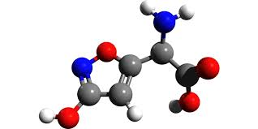

Contains 2 or more substances
Contains 1 type of atom

Is a pure substance (hint: there are two)

- Heterogenous or Homogenous? Look at each picture or word and determine if the mixture is homogenous or heterogenous mixture.
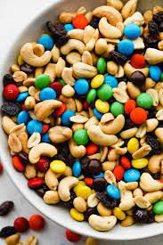

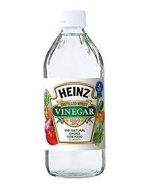
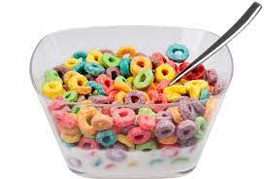

  - Determine if each sentence is describing a physical or chemical property.

Physical or Chemical Property?
Zinc is a grayish color
Water will boil at 100 ℃
Sodium will react with water forming hydrogen gas
The substance in the lab was brittle to the touch
In lab two substances were combined. This caused an EXPLOSION
Wow, that substance didn’t freeze until 23 K

  - Determine if each sentence is describing a physical or chemical change.

Physical or Chemical Change?
The ice cream that was left in the sun started to melt
In lab, two substances were added together. Without the mixture being set on a hot plate, the mixture started to heat up
You are in lab and all the sudden a gross smell starts coming from your beaker.
You left you water bottle in your car and the water inside froze
While cooking you notice that the pot with boiling water has condensation on the top of the lid
You put a penny in a solution and it changed colors

- Measurement Conversion.
Convert 1678 mg to g

Convert 50 m to cm

The average length of a great white shark is 640 cm. How long is the average length of a great white shark in micrometers?

The dinosaur has a temperature of 95.5 F. What is the dinosaur’s temperature in Celsius (℃)? In Kelvin (K)?
Formulas: ℃= (F-32) x (5/9)
0 ℃ = 273.15 K

