CHEM 1020 SI
Jan. 27th

Agenda:
Spotify playlist (write any ideas on the board)
Worksheet
Fun Chemistry Trivia

Questions:
- Classification of Matter: determine if each picture or word is an element, compound, or mixture.
Saline Solution

Element Mixture Mixture
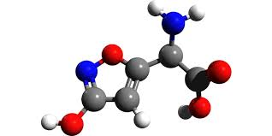

Contains 2 or more substances
Contains 1 type of atom

Mixture Compound Element

Element Compound
Elements
Compounds
Is a pure substance (hint: there are two)

- Heterogenous or Homogenous? Look at each picture or word and determine if the mixture is homogenous or heterogenous mixture.
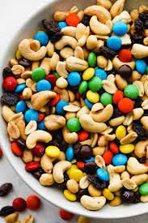

Homogenous Heterogenous
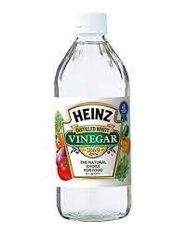
Heterogenous

Homogenous
Heterogenous Homogenous

  - Determine if each sentence is describing a physical or chemical property.
 | Physical or Chemical Property?
Zinc is a grayish color | Physical
Water will boil at 100 ℃ | Physical
Sodium will react with water forming hydrogen gas | Chemical
The substance in the lab was brittle to the touch | Physical
In lab two substances were combined. This caused an EXPLOSION | Chemical
Wow, that substance didn’t freeze until 23 K | Physical

 | Physical or Chemical Change?
The ice cream that was left in the sun started to melt | Physical
In lab, two substances were added together. Without the mixture being set on a hot plate, the mixture started to heat up | Chemical
You are in lab and all the sudden a gross smell starts coming from your beaker. | Chemical
You left you water bottle in your car and the water inside froze | Physical
While cooking you notice that the pot with boiling water has condensation on the top of the lid | Physical
You put a penny in a solution and it changed colors | Chemical

- Measurement Conversion.
Convert 1678 mg to g
$1678 mg x \frac{1x {10}^{-3}g}{1 mg}=1.678$

Convert 50 m to cm
$$50 m x \frac{1 cm}{1x {10}^{-2}m }=5000 cm$$

The average length of a great white shark is 640 cm. How long is the average length of a great white shark in micrometers?
$$640 cm x \frac{1x {10}^{-2}m}{1 cm }x \frac{1 μm}{1x{10}^{-6}m }=6400000 μm or 6.40 x {10}^{6}μm$$

The dinosaur has a temperature of 95.5 F. What is the dinosaur’s temperature in Celsius (℃)? In Kelvin (K)?
Formulas: ℃= (F-32) x (5/9)
0 ℃ = 273.15 K
$$°C=\left(95.5-32\right) x \frac{5}{9}=35.28 °C$$

$$K=35.28 °C+273.15=308.42 K$$

