SI Worksheet
4/24/22

Agenda:
Worksheet

Chapter 7: Thermochemistry
- Calculate the change in the internal energy of a system if 300J of heat energy is absorbed by the system and if 400J of work is done on the system. (700J)

- A sample of unknown metal with a mass of 192 g heated to a temperature of 100 °C was immersed into a brass calorimeter with a mass of 0.128 kg containing 240 g of water at a temperature of 8.4 °C. Provided that the water temperature stabilized at 21.5 °C, calculate the specific heat capacity of the metal and based on this value of capacity identify the metal.
Assume that the specific heat capacity of brass is 0.402 J/g*C, and water is 4.184 J/g*C

Substance | Specific Heat (J/g*C)
Helium | 5.193
Aluminum | 0.897
Lead | 0.130

- How much heat will be released when 11.8 g of iron reacts with excess O2 according to the following equation?

Fe + O₂ Fe₃O₄ H_{rxn}=-1120.48 kJ

- Given the following equations
(1) H₃BO₃(aq )→ HBO₂(aq) + H₂O(l) ΔH = - 0.02 kJ
(2) H₂B₄O₇(aq) + H ₂O(l )→ 4HBO₂(aq) ΔH = - 11.3 kJ
(3) H₂B₄O₇(aq) → 2B₂O₃(s) + H₂O(l) ΔH = 17.5 kJ

Find the ΔH for this overall reaction: 2H₃BO₃(aq) → B₂O₃(s) + 3H₂O(l)

Chapter 8: Quatum Mechanical Model of an Atom

- The wavelength of an X-ray is 0.483 Å. What is its frequency (in Hz)? The speed of light is 3.00 x 10⁸ m/s. 1 Å=10⁻¹⁰m. (6.21 x 10¹⁸ Hz)

- What is the energy (in J) of an X-ray photon with a wavelength of 4.83 x 10⁻² nm? The speed of light is 3.00 x 10⁸ m/s.

- Identify the subshell in which electron with the following quantum numbers are found:
  - n = 3, l = 2

3d

  - n = 1, l = 0

1s

  - n = 4, l = 3

4f
Chapter 9: Periodic Properties of Elements
- Draw the box diagram and electron configuration for each of the following elements.
Element | Box Diagram | Electron Configuration
Boron
Lithium
Oxygen
Phosphorus
Chlorine
Potassium
Aluminum

- Reactivity of halogens __________ down the group? (decrease)

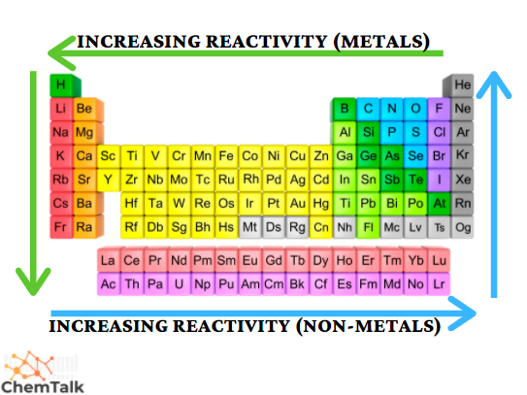
- What is the approximate “net” charge felt by the valence electron of…
  - Lithium
1s²2s¹
Therefore there is 2 core electrons, the nucleus has a charge of +3
+3-2= +1
  - Magnesium
1s²2s²2p⁶3s²
10 core electrons
Nucleus charge: 12
+12 – 10= +2

  - Oxygen
1s²2s²2p⁴
2 core electrons
Nucleus charge: 8
+8 – 2= +6

- The valence electron in which if the following atoms experience a larger attractive force from the core charge/effective nuclear charge? (right)

  - Which one is smaller? (right)

- List the following ions in order of increasing radius: As3–, Br–, K+, Mg2+.

